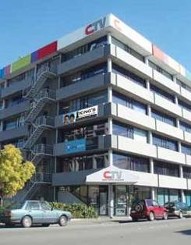

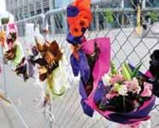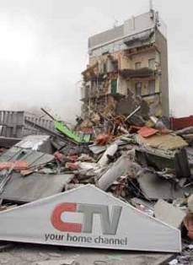FINAL REPORT
H.2

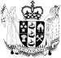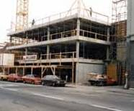

VOLUME 6
CANTERBURY TELEVISION BUILDING (CTV)

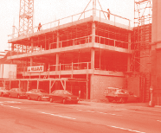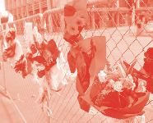

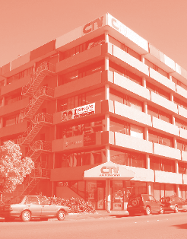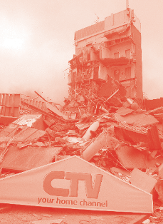C

A B D

A. The completed CTV building

B. The collapsed CTV after the 22 February 2011 earthquake
(source: Geoff Sloan/The Star)

C. The CTV building under construction
(source: Stephen Breach)

D. Floral tributes left at the former CTV building site
(source: Dylan Taylor)

ISBN: 978-0-478-39562-4 (Final Report Microsoft Word)

ISBN: 978-0-478-39576-1 (Volume 6 Microsoft Word)

Contents

Introduction
Section 1: The building
1.1 General description
1.2 Structure of the building
Section 2: The CTV building from 1986 until September 2010
2.1 Engineering design of the CTV building
2.2 The building permit
2.3 Construction
2.4 Drag bar retrofit
2.5 From 1991 to 4 September 2010
Section 3: From the September earthquake to the February earthquake
3.1 The Canterbury earthquakes
3.2 The September earthquake
3.3 Observations of damage between the September and Boxing Day earthquakes
3.4 Post–September earthquake rapid assessments
3.5 Engineer’s assessment of the building
3.6 Boxing Day earthquake
3.7 Demolition of the neighbouring building
3.8 The Clinic tenancy
Section 4: The February earthquake
4.1 Description of the February earthquake
4.2 Description of collapse by eyewitnesses
Section 5: Post-collapse investigations
5.1 Post-collapse examinations of building debris
5.2 Technical investigations by the former Department of Building and Housing
5.3 Technical investigations instigated by the Royal Commission
5.4 Technical investigation reports by others
5.5 The nature of the land associated with the CTV building
Section 6: Technical discussions on structure
6.1 Design earthquake loading and analysis of the CTV building
6.2 Landsborough House
6.3 The structural system of the CTV building
Section 7: The collapse
7.1 Introduction
7.2 Possible scenarios
7.3 Contributors to collapse
7.4 Most likely collapse scenario
Section 8: Compliance
8.1 Compliance with legal requirements
8.2 Best-practice requirements

Section 9: Summary of conclusions and recommendations
9.1 Structure of the CTV building
9.2 Engineering design of the building
9.3 Building permit
9.4 Construction
9.5 Building retrofit
9.6 The building from 1991 to the September 2010 earthquake
9.7 The September 2010 earthquake and post-earthquake assessments
9.8 The building from the September 2010 earthquake to 22 February 2011
9.9 The collapse of the CTV building on 22 February 2011
9.10 Reasons for the collapse
9.11 Issues with the structural system
9.12 Compliance with legal requirements
9.13 Compliance with best-practice requirements
9.14 The assessment of other buildings with potential structural weaknesses
9.15 Conclusion
Appendix 1: List of people mentioned in this Volume
Appendix 2: Chronology

Introduction

The CTV building at 249 Madras Street collapsed during the earthquake at 12:51pm on 22 February 2011. One hundred and fifteen people lost their lives and others were injured.

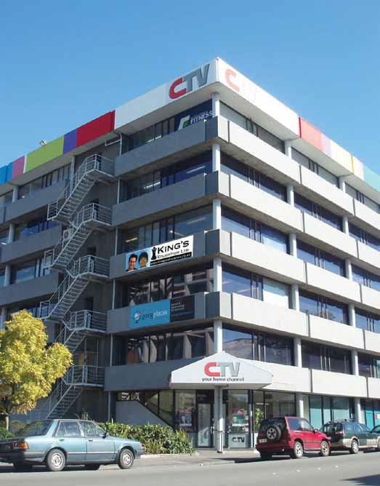

Figure 1: View of the south-east of the CTV building. Madras Street is in the foreground

Cathedral
Square

Latimer
Square

CTV
building

Cashel Street

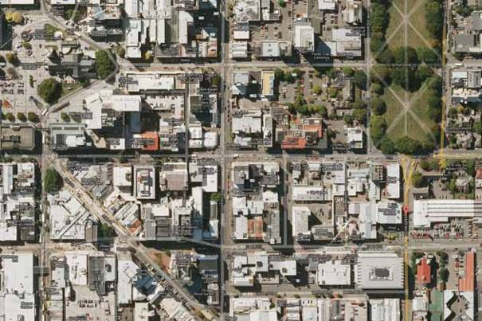Figure 2: An aerial view of the location of the building. Madras Street runs north towards Latimer Square

Those who died in the CTV building

Many parts of this report into the collapse of the CTV building are necessarily technical. However, throughout our Inquiry, we have not forgotten the 115 people who died, their families and their friends. Our thoughts have also been with the people who escaped the building after it collapsed, some of whom will carry serious injuries for the rest of their lives. We think particularly of the two 19-year-old Japanese students, Kento Okuda and Rika Iwakura, who both had a leg amputated following the collapse. Their lives have been changed forever. We appreciate the courage shown by those who retold their experiences during the hearing.

To honour and remember those who died, we asked their family members to tell us about them. The words that follow reflect what they said. We thank the families for their willingness to share this information publicly.

We also thank Mr Yucai Li, Consulate General of the People’s Republic of China in Christchurch, Mr Yasuhide Sakamoto, Third Secretary:
Protocol & Political section, Embassy of Japan in Wellington and Mr Tsuyoshi Shimbo, Chief of Family Liaison Team, Japanese Nationals Overseas Safety Division, Ministry of Foreign Affairs of Japan for their invaluable language support with this project and for always generously giving their time to support and liaise between the families and the Royal Commission. We would also like to thank Susan Urakami from the Toyama College of Foreign Languages in Japan and Liam Cai from the Christchurch Chinese community for all the support they have provided to the families and the Royal Commission.

Our thanks also go to The Press newspaper for biographical information from their supplement ‘In Memoriam’, which was published on 22 February 2012.

The biographies below all relate to people who were working or visiting in the building when the earthquake struck. Biographies of others who died in other parts of Christchurch as a result of the earthquake are published elsewhere in this Report.

Maysoon Abbas

Dr Maysoon Abbas, 61, was a medical doctor who graduated with a Bachelor of Medicine and Surgery from Baghdad
University and Master of Medical Science from Sheffield University, United Kingdom.

She was working at The Clinic medical centre examining a patient in her office on the east side of the CTV building when the earthquake struck.

Maysoon enjoyed art, especially handcraft and painting. She was creative, loved travelling and was a great cook.

She was a very caring person who loved her family and was known for her infectious smile. When she loved, she loved with all her heart. She was strong, determined and passionate about her profession.

Maysoon is survived by her husband of 35 years, Maan Alkaisi, daughters Sarah Alkaisi, Marwa Alkaisi and Mariam
Alkaisi, and granddaughter Sally, aged five.

Lalaine Agatep

Ms Lalaine Agatep, 38, was a registered nurse from the Philippines who was studying English at King’s Education language school.

Lalaine enjoyed reading, surfing the internet and spending time with friends and family. She was a quiet, kind-hearted person who was obedient and loved her family.

She is survived by Linda Agatep (mother), Lee Agatep (father), Leelin Agatep (sister), Lorelie Agatep (sister), Leah Agatep (sister) and Leila Agatep (sister). Lalaine’s sister Leila lives in Wellington, New Zealand, and the rest of her family live in the Philippines.

Husam Al-Ani

Dr Husam Al-Ani, 55, was a medical practitioner working at The Clinic medical centre. He was examining a patient when the earthquake struck.

Husam loved spending time with family, and playing and watching sport, soccer and tennis in particular. He enjoyed jogging, gardening and exploring new outdoor activities.

Husam was a loving husband and father, and a passionate, honest gentleman. As a loving family man, he was a role model and an exemplar for his daughters. Wherever he went his charming smile, his quiet calm and his ability to empathise ensured that he was popular with everyone. Since 1998 he had lived in Christchurch and he loved the city.

Husam was a very generous man who donated hundreds of hours of his time to the Youth Health Trust in Christchurch. His family feel that he died in service and he would not have wanted it any other way. His wife said: “Husam you are a man who lived as a hero, left as a hero and are survived by three young heroines”.

Husam is survived by Dr Wasan Al-Ani (wife), Azza (daughter, aged 24), Aysha (daughter, aged 22) and Haya
(daughter, aged 17).

Mary Amantillo

Ms Mary Amantillo, 23, was a Filipino nurse who arrived in New Zealand with close friend Valquin Bensurto just over a week before the earthquake. She was studying English at King’s Education language school.

Mary sent text messages to her mother in the Philippines as she lay in the rubble of the building. Her first message said: “Ma, I got buried”. Forty minutes later she texted: “Ma, I can’t move my right hand”. Mary’s friend Valquin also died in the building.

Emmabelle Anoba

Ms Emmabelle Anoba, 26, was a Filipino nurse who was studying English at King’s Education language school as an employment requirement. Emmabelle had been studying at King’s Education for just two days before the earthquake.

Emmabelle had two siblings. Her younger sister, Aprille, posted on her Facebook page after the earthquake, “Wish I could hug you and tell you how much I love you”.

Marina Arai

Ms Marina Arai, 19, was a Japanese student from Toyama College of Foreign Languages. She had arrived in
Christchurch three days before the earthquake and was studying English at King’s Education language school.

Marina’s family describe her as a diligent student who wanted to improve her English. She had hoped to become a flight attendant or an animator.

Marina was a sincere and warm-hearted person with a delightful smile and a good sense of humour. She had a passion for Japanese tea coordination, and loved making sweets to match tea served in fine china.

Marina is survived by her father, mother, older sister, and a pet rabbit.

Matthew Beaumont

Mr Matthew Beaumont (known as Matty), 31, was a programme scheduler and movie reviewer for CTV. He was at work when the earthquake struck.

Matty was a keen movie buff and a big Doctor Who fan who for some time was a member of the Doctor Who fan club. Best of all he enjoyed being with his friends, having a laugh.

Matty was the adopted child of Jeannette and David Beaumont. He came to them when 10 days old and had a gentle, placid nature which he never lost. He was the epitome of laughter. His wit, intellect and cheeky smile were contagious and enveloped everyone who met, knew and loved him. He was also incredibly brave; although sensitive to an unkind word or review he would go on committing himself time and again to connect with and entertain people.

Matty had found the perfect partner. He loved his parents and friends and was loved in return. He was truly happy and optimistic about the future.

He is survived by Kelly Thorndycroft (partner), and Jeannette and David Beaumont (parents).

Dominic Bell

Dr Dominic Bell, 45, was working as a general practitioner at The Clinic medical centre when the earthquake struck. Dominic enjoyed jet skiing, snow skiing, watching rugby, cricket and movies, and he appreciated fine wine.

Dominic was an intelligent, loving, generous man who was a wonderful dad. His three sons were the greatest love of his life. He had a brilliant but often offbeat sense of humour and an ability to turn something seemingly ordinary into laughter to brighten anyone’s day.

He is survived by Harrison (son, aged 18), Matthew (son, aged 14), Theo (son, aged 11), who were all living with their mother Vicki; Alison Bennie (partner) and her three children Tom, Porsche and Trinity; his sisters Virginia and Leonie, and his brothers Martin, Anthony, Damian and Matthew.

Valquin Bensurto

Mr Valquin Bensurto, 23, was a Filipino nurse who left for New Zealand with his close friend Mary Amantillo on February 12, 2011. They were studying English at the King’s Education language school. Taking English lessons was an employment requirement for the nurses.

Valquin came from Jaro District in Iloilo City. He was a keen sportsman and enjoyed playing football and volleyball.

Heidi Berg

Ms Heidi Berg, 36, was teaching English as a foreign language at King’s Education language school when the earthquake struck. Her class included many of the newly arrived Japanese students from Toyama College of Foreign Languages.

Heidi was a graduate of the University of Canterbury and had completed TEFL and TESOL qualifications in the United
Kingdom and Australia. She was a dedicated and conscientious teacher who taught foreign language students from all over the world.

Heidi had travelled from the North to the South Pole and to many countries. She enjoyed touch rugby, swimming, cricket, walking her dog, driving, reading and spending time at the family holiday house in the high country.

Heidi was a loving, dependable, thoughtful, kind person with a great smile. She was the glue that kept her family and extended family connected throughout the world. She was loved by all her family members, including her granddad, aunties, uncles, cousins, and also by her friends.

She is survived by Alan (father), Julie (mother), Stephen (brother), Justine (sister), John (brother-in-law), Josh and
Thomas (nephews), Chloe (niece) and her pet dog, Texas.

Andrew Bishop

Mr Andrew Bishop, 33, worked for CTV as a technical manager for the station. When the earthquake struck he was working with Jo Giles and editing a piece for Woodford Glen Speedway. He had returned from his lunch break and headed back upstairs to resume his work only a few minutes before the earthquake struck.

At CTV Andrew was involved with camera operating, editing, sound technician work, voice-overs, and other aspects of television production. He also worked at rugby games doing match communications and had his own editing company called Ribeye Productions.

Andrew was a fun person and loved to go on road trips with his partner Amber and the three boys they had between them. He liked fishing, camping and was a member of the Sumner Lifeboat crew. He also enjoyed practising on his electric guitar and ukulele and playing on his iPhone.

Andrew had a great personality and could get along with anyone. He had a cheeky smile, contagious laugh and was highly respected. He was a great role model, but also lots of fun for the children at the same time. Andrew loved creating an entertaining atmosphere wherever he went and having home barbecues with family and friends. The more the merrier.

He is survived by Amber (partner) and her two sons, Tyler (Andrew’s son, currently aged 7), Karen (mother), Lyndsey
(father), Anita (sister), Ben, Sam and Jake (half-brothers) and Nicole (niece).

Nina Bishop

Ms Nina Bishop, 32, was an administrator for Relationship Services in the CTV building. The staff at Relationship
Services were like a second family to her. Nina loved her job and her workmates.

For Nina, her family was the centre of her world. She lived with her mother, Vivienne, and they were best friends.
Nina was an optimist with a tight group of friends. It was impossible not to love Nina and she had an amazing capacity for giving and caring for those around her, from friends and family to workmates.

Nina loved books and movies and had a fascination with ancient Egypt. She made her dream trip to Egypt in the
September before she passed away.

Nina was a loving daughter to Vivienne Bishop (mother) and a loving granddaughter to Enda Bishop (grandmother). Nina is also survived by Tracey, Nicole and Brett (siblings), and Sarah, Morgan, Brandon and Zeph (nieces and nephews).

Pamela Brien

Mrs Pam Brien, 54, had worked for the New Zealand Police for 17 years and was a member of the Christchurch child abuse unit. She was attending a work-related appointment with psychologist Ms Susan Selway at the CTV building when the earthquake struck. Susan also died in the earthquake.

Pam was a hard-working, loyal, dedicated and caring person. She always had an interest in other people and others would confide in her. Police colleagues described her as a very well-organised person who was dedicated to the cause, efficient, hard-working and a loyal friend and colleague.

Pam had started her career with the Police in New Plymouth as an assistant to an area commander in the Criminal Investigation Branch (CIB). New Plymouth CIB head Detective Senior Sergeant Grant Coward described Pam’s death as an “absolute tragedy”.

She is survived by Geoff Brien (husband) and Amie Booker (daughter, aged 30).

Rhys Brookbanks

Mr Rhys Brookbanks, 25, was a journalist for CTV. He was interested in working in investigative journalism but also had a great future ahead of him as a writer and poet. Rhys was busy preparing an article for evening broadcast
on the day the earthquake struck.

Rhys loved travelling both within New Zealand and overseas, all sports, but particularly rugby and rowing, and he played in a mixed netball team. He owned a mountain bike and enjoyed the challenge of cycling through rough terrain as well as family weekend rides. He was well-read and a published poet. Rhys enjoyed pub quiz evenings as he had a wide general knowledge. He had a flourishing vegetable garden and loved to cook. He also played the guitar and enjoyed a wide range of music.

Rhys was a gentle, kind, caring, thoughtful man. He had a quirky sense of humour, loved practical jokes and terrible puns, and had a giggle that still rings in his family’s ears. Rhys was very much a family man, always keen to visit his aunts, uncles and cousins, and was a good, amusing correspondent.

Rhys is survived by Fran Brookbanks (mother), Alan Brookbanks (father), Donna Brookbanks (sister) and Esther Jones
(fiancée).

Ivy Cabunilas

Mrs Ivy Cabunilas, 33, came from Consolacion in the Philippines and was living in New Zealand with her husband and their 11-year-old twin daughters. She was studying English at King’s Education language school and died alongside fellow Filipino students.

Cai Yu

Mrs Cai Yu, 31, was a nurse from Shanghai, China, who was studying English at King’s Education language school.

Yu was fulfilling her biggest dream to study abroad when she left for New Zealand in April 2010. She always spoke with her husband about how one day they would have a wonderful life in New Zealand. They would sit together after dinner as a family and play with their daughter. They would drive to see the ocean, and the snow-capped mountains. They would buy a little house with a garden where she would plant her favourite tulips. Her husband says the earthquake of 22 February took away those beautiful dreams and his beautiful wife.

Yu had returned home to China for a two-week holiday in December 2010. Her husband says it was like a farewell arranged by God. They went to Hong Kong and visited Disneyland. Yu’s daughter, who was three when her mother died, remembers going to the airport to meet her when she came home for the holidays. When she misses her mother she says to her father, “Daddy, let’s go to the airport to get Mummy. She’s waiting there for us”.

Yu was a person who loved to laugh and was always compassionate to others. Everyone loved her and doctors and nurses called her ‘little sister Cai’.

Yu is survived by her husband and her daughter.

Cristiano Carazo-Chandler

Mr Cristiano Carazo-Chandler, 35, was teaching at the King’s Education language school when the earthquake struck. He was the son of Faye Chandler and Pedro Carazo. Known as Christian, he was born in Spain and came to New Zealand with his parents when he was three.

He obtained a Bachelor of Arts in Human Geography and Sociology and a Master of Arts in Geography at the University of Canterbury. The subject of his MA thesis was Cyberspace – Another Geography:Territories, Boundaries and Space. He then gained a Diploma of Teaching and started his career as an English teacher in South Korea, the United Arab Emirates and Spain.

Christian was a personable young man who loved to travel but had decided to spend time in Christchurch getting to know his young siblings before setting off overseas again. His ambition was to lead a fulfilled life and he planned to teach in less advantaged countries.

Chen Yang

Mrs Chen Yang (known as Sunny), 29, was a Chinese student studying English at King’s Education language school. Yang had flatted with another earthquake victim, Wang Limin.

Yang was a happy, optimistic, positive woman who was like a ray of sunshine. Her smile always spread to the people around her and wherever she went she brought positivity with her. She loved to travel and cook. Before she left China she had developed an interest in Western cooking and made delicious pizza.

Yang deeply loved her parents, her husband and her little son and she always hoped they would soon be reunited. She is survived by her parents, her husband and her son (aged two).

John Chua

Mr John Chua, 23, was a Filipino nurse who arrived in Christchurch on February 20 and was studying English at King’s
Education language school. John, who was known as JK or Insik, lived in Cebu city in the Philippines.

John was a man who lived a simple life but touched a million lives. He was a tender-hearted gentleman who loved animals and children. His joviality and good nature attracted people to him and no one could forget his enthusiastic and contagious laugh.

John was adventurous and loved exploring the world. He was always there to pick up the pieces and sort things out. He was his wife’s soulmate and her inspiration; her steadfast rock who helped her through thick and thin.

John is survived by Yoradyl Chua (wife) and Yojwan (his young son).

Susan Chuter

Ms Susan Chuter, 52, was an advertising representative for CTV. She had been with the company for only three weeks, after having left Mainland Press in The Press building. Susan had changed jobs fearing The Press building to be unsafe. When the earthquake struck she had just entered the building, making her way to her desk to complete some paperwork after having signed a contract with a new client for CTV.

Susan enjoyed being a mum and a homemaker. Cars were one of her passions and she liked going to Ruapuna Speedway in the weekends. She loved entertaining, socialising with the many friends who were part of her life, and travelling.

She was a vivacious person who lit up a room; a great communicator who made people feel at ease, was fun and always looked on the bright side.

Susan is survived by her father who lives in England, Gillian Chuter (older sister), three sons aged 37, 34 and 23 and a grandchild.

Tamara Cvetanova

Dr Tamara Cvetanova, 42, was a student at the King’s Education language school. She was a former paediatrician in Serbia and had come to Christchurch to raise her family and register as a doctor in New Zealand. She arrived in Christchurch in 2000 and started studying English in January 2011 as an employment requirement.

Tamara was a devoted mother and wife who loved Christchurch and was a firm believer in the New Zealand system. She had spoken to her husband on the phone intermittently up until 1am on 23 February as she lay in the rubble. Tamara was a member of the Russian Orthodox Church of St Nicholas. Her husband will stay in Christchurch with their two children because Christchurch is where she wanted to be.

Tamara is survived by Alec Cvetanov (husband), Todor (son, aged 10) and Katerina (daughter, aged eight).

Joanna Didham

Mrs Joanna Didham (known as Jo), 35, was an advertising producer for CTV. She was in a meeting with CTV’s managing director Murray Wood when the earthquake struck.

Jo loved her family, cooking and gardening. She was on the Parent Teacher Association for her daughter Madison’s school. She also loved her orange Volkswagen Beetle.

Her family describe Jo as elegant, dedicated, beautiful inside and out, and an organiser. She is survived by Michael (husband of 13 years), Madison (daughter, aged seven), Jessica (daughter, aged three), Ashley and Brandon (brothers), Geoff (father) and Lorraine (mother).

Dian Falconer

Ms Dian Falconer, 54, was working as a receptionist at The Clinic when the earthquake struck. Before she joined the staff at The Clinic she had worked in a nursery growing native plants at Wai-Ora Forest Landscapes.

Dian grew up in Timaru and would visit her sister there, bringing baking with her. Dian went to church every week and also enjoyed being in her garden. She is described by her sister as so precious, caring, kind to animals, lovely and happy-go-lucky.

Dian is survived by Jenny (sister), Teremoana and Mania (children) and three grandchildren.

Jewel Francisco

Ms Jewel Francisco, 26, found New Zealand peaceful, clean and beautiful. She arrived in New Zealand weeks before the February earthquake and was studying English at King’s Education language school. She came from Cavite City in the Philippines.

Jewel liked sport and was a competitive swimmer. She studied nursing and chose to come to New Zealand to improve her English and try to register as a nurse. She was aware of the September earthquake and her family had asked her to reconsider her decision to go to New Zealand but she had told them, “If it is my time to join my Creator, then it is my time to go with Him”.

She is remembered as a strong, down-to-earth young woman who could take care of herself. She loved cooking and was also fond of dogs and owned three of them. Friends travelled from other countries to attend her wake and pay their respects as she had touched a lot of lives.

Jewel is survived by Ronaldo (her father, whom she adored), Robbie Leigh (older brother, who is also a nurse in the United States of America) and Renz (younger brother). Jewel was also a very caring aunt to Ronzer (nephew) whom she loved very much.

Samuel Gibb

Mr Samuel Gibb (known as Sam), 27, was a CTV news producer who was at his desk when the earthquake struck.

Sam was a bubbly person with a great sense of humour. He was sincere and dedicated to delivering good journalism. Sam’s hobbies included playing guitar and listening to music, reading, playing football, brewing beer, fishing and the outdoors.

Sam is survived by Cindy (wife), Carol Gibb (mother), Laurence Gibb (father), Kristen (sister), Cameron (brother), Anna (sister-in-law to be), and Asreal (his cat).

Joanne Giles

Ms Joanne Giles (known as Jo) was a business development manager at CTV.

Jo represented New Zealand in pistol shooting at two Oceania Games and a World Cup. She was New Zealand’s first female jockey to race against men, and competed in motor sport and rock ‘n’ roll competitions. Jo was a candidate for the ACT New Zealand political party in 2005 and was a mayoral candidate in the 2007 Christchurch local body election. Jo constantly challenged herself and liked to break down stereotypes by excelling in male-dominated sports or activities.

As someone with a very empathetic nature, Jo always had the time to listen to other people’s problems, despite living a busy life. She believed that a problem shared was a problem halved. She always had time for her family and would have done anything for her children. Jo was constantly laughing and was often the life of the party. She always had something on the go and lived life to the fullest.

Jo is survived by her children Anna, Samantha, Olivia and James.

Elizabeth Jane Grant

Mrs Jane Grant, 51, was a practice nurse at The Clinic. She had been a nurse for over 10 years following a career with
New Zealand Railways as a train controller.

Jane loved being at home and her hobbies included gardening, cooking, knitting and doing things with her family. She also loved dancing and playing her accordion. She liked going for trips in the campervan and loved animals, especially dogs.

Jane was generally a quiet-natured person but would stand up for herself when she had to. She was a loyal friend, loved her family and had compassion for other people.

She is sadly missed and survived by Murray (husband), Christina and Nickolas (daughter and son from her previous marriage) and Jenny (her much-loved Cocker Spaniel).

Yuki Hamasaki

Ms Yuki Hamasaki, 23, was having a lesson at King’s Education language school when the earthquake struck.
After graduating from a Japanese university she entered Toyama College of Foreign Languages and then travelled to
New Zealand to study.

Yuki enjoyed listening to music from various countries and liked house parties. She was a person who always laughed and created a cheerful atmosphere around her. She was shy but had a strong will and was loved by many people.

Yuki is survived by her father (aged 57), mother (aged 45), three sisters (aged 21, 20 and 16) and one brother (aged 18).

Han Xiling

Ms Han Xiling, 25, was a Chinese nurse studying English at King’s Education language school.

Xiling had dreams of becoming a registered nurse in New Zealand. Xiling was born in Jiangsu, China, and completed her undergraduate degree in 2008. She worked at Nantung Hospital until she decided to seek further education and she travelled to New Zealand in November 2010.

Xiling enjoyed singing and dancing, especially modern dance. She worked hard, was economical with money and was a friendly person.

Her parents said they had lost everything when Xiling died. When they first heard about the collapse of the CTV building they had hoped for a miracle. In Chinese culture parents rely on a child emotionally and financially a great deal, especially when they grow old. They explained that under the Chinese way a child has an obligation to look after their parents. They are sad and devastated, having spent everything they had on their daughter. They buried Xiling in Christchurch and want to return to New Zealand every year to visit her grave and be buried beside her when they die.

Xiling is survived by Han Siyin (father) and Wang Luxia (mother).

Tamara Harca

Mrs Tamara Harca (known as Lia), 59, who was originally from Romania, was an English teacher at King’s Education language school. She had been an English lecturer at the University of Craiova and came to New Zealand in 2001. Lia was a senior teacher and teacher trainer at the language school and she had also trained teachers in Romania and Europe.

Lia’s husband, Petre Harca, had joined her in Christchurch in 2003 but health problems prevented him from working. Their sons, Sebastian and Nicholai, joined them in 2004 but Nicholai has since returned home.

Lia was the breadwinner of her family. The money she earned went towards establishing a base in New Zealand, supporting her sons and getting her family to Christchurch. She was her husband’s moral and financial support.

Lia is survived by Petre Harca (husband), and Sebastian and Nicholai (sons).

Yuki Hasumoto

Ms Yuki Hasumoto, 22, was from Toyama College of Foreign Languages in Japan. She was part of a group who arrived in Christchurch on 19 February on a three-week study and homestay programme.

Yuki had been interested in working abroad one day and had already visited England and Australia when she was a young student. At a young age Yuki became interested in cooking and later, as a student at a culinary school, she travelled to France and Italy, where she earned praise from a pizza chef. Yuki loved music and making sweets. She had many friends and enjoyed going for drives and visiting coffee shops and cafes with them.

Yuki was cheerful and outgoing with a positive attitude. She came from a large and loving family, consisting of her parents, grandmother, two brothers, a sister-in-law, a sister, a brother-in-law and three nephews.

Yumiko Hata

Ms Yumiko Hata, 29, was a Japanese nurse who was on leave from work to obtain an international nursing licence and study English at King’s Education language school. She was probably having lunch with friends in the classroom when the earthquake struck.

Yumiko was always cheerful, lively and full of smiles. She cared about her friends and worked hard towards her goals. She loved books and would spend every spare moment reading.

Yumiko is survived by her father, mother, elder sister, elder brother and a younger sister.

Miki Hayasaka

Ms Miki Hayasaka, 37, was a Japanese nurse studying medical English at King’s Education language school. After completing her training at the Nursing School of the National Centre for Global Health and Medicine in Japan, she worked as a nurse in Japan at the Cancer Institute Hospital, Yokohamashintoshi Neurosurgical Hospital, Suzuki Orthopaedic Clinic (Morioka City) and Yokohama Miyazaki Hospital of Neurosurgery.

Miki liked music and singing. She enjoyed singing with friends at a local gospel song club and singing at concerts. She also liked travel and photography and enjoyed taking snapshots while travelling. When she returned to her home town once or twice a year she organised family trips.

Miki was cheerful and lively, goal-oriented and had a strong sense of responsibility. She always wanted to improve herself
in her work and was kind to everyone. She loved children and they loved her. She took good care of her nephew and niece. Miki is survived by her parents (both 70 years old), two older sisters (both married) and an older brother.

He Wen

Ms He Wen, 25, was a Chinese nurse who was studying English at King’s Education language school.

Wen came from Fuzhou in China where she had been working as a nurse in the neonatal unit in Dongguan Hong Wah Hospital. Colleagues said she was quiet, hard-working and a really good nurse, and her former boss described her as excellent, highly skilled and reliable. He also said her English was excellent and she could communicate with foreign patients at the hospital. Wen resigned in 2010 and came to Christchurch to study English. She had originally hoped to travel to Italy but discovered it would take too long to get the documents, so chose New Zealand instead.

Wen would send money home to China every month to put her younger brother through university. Her father was retired so Wen had become the support person for her brother. Wen had been in Christchurch for the September 2010 earthquake and felt that New Zealand’s houses had come through quite well and passed the test.

Sandra Jen Jin Hii

Ms Sandra Hii, 34, worked as the administrator/receptionist at King’s Education language school, registering and welcoming new students.

Sandra was a kind, gentle, loving and considerate person who was always willing to give a helping hand to those who were in need. She enjoyed reading the Bible in her spare time and also sharing her faith in the Lord Jesus with others.

She is survived by her parents and siblings.

Marion Hilbers, nee Berry

Ms Marion Hilbers, 49, was a receptionist at The Clinic medical centre.

Marion was a devoted and loving mother to sons Josh (aged 22) and Sam (aged 20). She has been described by her family as caring and extremely generous and she had a heart of gold that was for everyone.

Marion was born in Christchurch and has five brothers and one half-sister. She attended Aorangi Primary School, Cobham Intermediate, and Burnside High School. Her favourite colour was pink and she loved things that sparkled. Marion had a fascination with the stars in the night sky. She also doted on her two cats, Precious and Sylvia. She is sadly missed by her family and friends.

Yuko Hirabayashi

Ms Yuko Hirabayashi, 28, was studying English at King’s Education language school. Her family felt she was probably chatting with her friends in the classroom when the earthquake struck. In Japan, after graduating from Kobe University, Yuko had worked as a midwife for three years.

Yuko was an easygoing, caring, thrifty person with leadership abilities. She was a very steadfast person who did not compromise easily, never spoke ill of others, made friends with everybody, worked hard towards achieving her dreams and loved small children very much.

Yuko was excellent at Kendo (3-dan) and while in New Zealand attended a Kendo club where she used her gear brought from Japan and was entrusted with teaching children. She always enjoyed socialising with her peers.

Yuko is survived by her parents, grandparents, younger brother and younger sister.

Yoshiko Hirauchi

Mrs Yoshiko Hirauchi, 61, was a former high school principal in Japan. She had retired in 2010 to study English and was at the King’s Education language school when the earthquake struck.

Yoshiko loved and excelled at studying. After she graduated from university she became a high school biology teacher but continued to study and conduct research on soil creatures, eventually discovering a new type of soil bacterium. She later became principal at Namerikawa High School in Toyama Prefecture. After her retirement, Yoshiko wanted to return to university fulltime and continue her research. She wanted to study English first so she would be able to write her thesis in the language.

Yoshiko enjoyed travelling, gardening and watching Korean TV dramas. She was kind to everyone. The younger students at her school loved her and because of her warm and understanding heart they saw her as their second mother.

Yoshiko is survived by her husband, two daughters and a grandson.

Megumi Horita

Ms Megumi Horita, 19, from Japan was studying English at King’s Education language school. She was having lunch when the earthquake struck. Megumi was about to embark on a career and had planned to enter university after graduating from Toyama College of Foreign Languages.

Megumi enjoyed table tennis and calligraphy. She loved wearing hats and took a white one with her to New Zealand, which was retrieved after the earthquake.

Megumi is described by her family as pure and innocent, open-hearted and kind to everyone. She had friends from junior high school who were deaf or had problems with non-attendance at school. She was described by her friends as a very truthful person who never told a lie.

She is survived by her father (aged 56), mother (aged 51) and two brothers (aged 20 and 22). She was particularly loved by her parents and grandparents as the youngest child. Her parents mourn her loss and feel empty without her.

Hifumi Hoshiba

Ms Hifumi Hoshiba, 41, was a Japanese nurse studying English at King’s Education language school.

Hifumi had extensive experience in nursing at various general hospitals in Tokyo and other places and had been an ER nurse and a flight nurse. She was also an advanced cardiovascular life support provider. Hifumi studied English during her career in Japan and later participated in language training courses for medical professionals in both Oregon and California in the United States of America, before she came to Christchurch for further language training. She wanted to become a nurse who could work globally.

Hifumi enjoyed tennis, scuba diving and wind surfing when she was in her 20s and was practising flower arranging in recent years. She was a positive, forward-looking person who was hard-working and faithful to her principles. She was a thoughtful sister, personally handing out Christmas gifts to everyone in her family every year.

Hifumi is survived by three brothers and a sister.

Huo Siwen

Ms Huo Siwen, 28, was from Harbin in China. She had arrived in New Zealand in 2002 to get her Master’s degree and was working as a journalist for CTV when the earthquake struck. She was engaged to be married in 2011 and her fiancé was also in New Zealand at the time of the earthquake.

Siwen had studied science at Heilongjiang University and her family supported her decision to study in New Zealand. She stayed with a Christchurch family when she first arrived in New Zealand and had maintained contact with them over the years.

Siwen was an intelligent and beautiful girl. She is survived by her fiancé, Li Xin, Zhilin Huo (father, aged 55) and
Shuxin Liu (mother, aged 55).

Haruki Hyakuman

Mr Haruki Hyakuman, 27, was a Japanese nurse studying English at King’s Education language school. He had worked as a nurse at Kanazawa University Hospital in Japan for four years before coming to New Zealand, and was having lunch in the classroom when the earthquake struck.

Haruki’s hobbies were travelling, music and his PC. He was an independent, bright and cheerful person who had a strong sense of responsibility. He was kind and always cared about his friends.

Haruki is survived by his father (aged 59), mother (aged 59), sister (aged 30), and three pet dogs.

Rika Hyuga

Ms Rika Hyuga, 30, was a Japanese nurse studying English at King’s Education language school.

Rika was born in Tokyo and went to a private school in Yokohama. She majored in nursing at Jikei University’s Faculty of Medicine. She had worked as a nurse at the university hospital from 2002 to 2010. While she understood the importance of sophisticated medical technology, her goal was to be a nurse who places more value on humanity and warmth, and being able to share a patient’s anxiety and pains. Rika wrote a poem about working as a nurse and the last three lines read, “The world is like a jigsaw puzzle made of a thousand pieces. Smiles and trust are two small pieces next to each other. If these two do not stand by one another, then the whole world will shatter”.

Rika was a keen football player and scuba diver. She used to dive at overseas locations six or seven times a year. She also enjoyed learning English.

Rika was an only child and is survived by her parents.

Toshiko Imaoka

Ms Toshiko Imaoka, 34, was a Japanese nurse studying English at King’s Education language school. She had been working as a nurse at hospitals in Okayama and Osaka in Japan.

In Japan, Toshiko enjoyed travelling. She also practised flower arrangement. In New Zealand, she loved visiting different cafes and developed a liking for coffee. She ended up attending a training school in New Zealand to become a barista.

Toshiko was a kind-hearted person who expressed her emotions directly. She possessed the inner strength to carry out her intentions once she had made a decision.

She is survived by Tatsuji Imaoka (father), Haruko Imaoka (mother) and Kazuhiro Imaoka (younger brother).

Thanydha Intarangkun

Ms Thanydha Intarangkun, 36, was a nurse from Thailand who was studying English at King’s Education language school. Her body was found in a search of the rubble on 24 February.

Tomoki Ishikuro

Mr Tomoki Ishikuro, 19, was a student from Toyama College of Foreign Languages who was studying English at King’s Education language school. His English teachers praised his English pronunciation and said he had a great broadcasting voice.

Tomoki was a well-mannered and cheerful young man who loved heavy metal music. One of his prized possessions was his electric guitar and he spent many hours practising on it. He carried his guitar pick with him wherever he went, including to New Zealand. Tomoki was always kind and would go out of his way to help others or cheer them up without hesitation.

Tomoki loved cycling and often went on long-distance trips with his father and younger brother. He enjoyed watching local Japanese trains and was interested in American muscle cars.

Tomoki was raised in a large, happy family and lived with his parents, younger brother, grandparents and great- grandparents.

Kyle Jack-Midgley

Mr Kyle Jack-Midgley, 27, was the area manager for Ashley and Martin Medical Hair Centres (Christchurch and Wellington). Kyle had taken up his new position with Ashley and Martin and moved to Christchurch from Auckland three weeks prior to the February earthquake. At the time of the earthquake he was consulting with colleagues and clients.

Kyle enjoyed being with his family. He loved the outdoors including sun, sport and fishing. He liked travelling, meeting people, learning new things and exploring new adventures. He loved life. His favourite quote was, “Dream as if you’ll live forever, live as if you’ll die today”, by James Dean.

Kyle enjoyed life for what it was, from relaxing in the sun to debating politics. He was an all rounder in sport and academic areas and was respected in all walks of life for his integrity, charisma and diligence. He had a big heart and a big smile. He had a special aura that attracted people to him. Kyle was very family-oriented and a people person who was always there for you if you needed help. Kyle’s way was to “do it once and do it properly”.

Kyle was the beloved partner of Olivia, cherished son of Suzanne Jack and Neil Midgley, much loved elder brother of
Wade, Ryan and Nathan, and adored uncle of Nathan, Phoenix, Aaliyah, Trinity and Karma.

Jin Man

Ms Jin Man, 26, was a Chinese student studying English at King’s Education language school. She came from Hebei province in northeast China. She came to Christchurch in September 2010 to study international management at King’s Education.

After her death a message from Man Jin’s family read, “You might not be anymore, but you’ve left us with endless memories. Everything’s well at home; you don’t need to worry. We’ll always love and miss you”.

Kayo Kanamaru

Ms Kayo Kanamaru, 19, arrived in Christchurch only days before the February earthquake. She was studying English at
King’s Education language school with her school friends from Toyama College of Foreign Languages. When she was at high school Kayo had gone on a two-week exchange to the United States of America. She had such a meaningful experience in the United States that she wanted to go abroad again to study English. She chose New Zealand because she wanted to follow in her older sister’s footsteps.

Kayo enjoyed watching movies and dancing. She had been a member of the dance team for the Toyama Grouses men’s basketball team and would perform during half-time. Kayo also dreamed of working in the film industry.

Kayo was a bright, friendly, kind girl with a radiant smile that warmed people’s hearts. She is survived by her two sisters, parents and grandparents.

Kyoko Kawahata

Ms Kyoko Kawahata, 20, was attending the orientation at King’s Education language school to prepare her for the three-week programme there when the earthquake struck. She was a student at Nara Women’s University in Japan, majoring in English literature.

Kyoko enjoyed reading books, listening to music and playing the piano. Her family describe her as shy, cooperative, thoughtful and diligent. She made many friends both at her university and through a part-time job because of her good nature and sweet spirit.

Kyoko is survived by Kuniaki Kawahata (father, aged 58), Kuniko Kawahata (mother, aged 55), Naoko Kawahata (sister, aged 28), Tomoko Kawahata (sister, aged 26), Ikuko Kawahata (sister, aged 23), Hiroyasu Kawahata (brother, aged 18) and Sadako Kawahata (grandmother, aged 80).

Beverley Faye Kennedy

Mrs Faye Kennedy, 60, was the practice manager of The Clinic medical centre. As such, Faye was responsible for the efficient running of all its aspects.

Outside of work, her interests were her family, house, garden and tennis. Faye was involved in tennis for 50 years, including playing, junior tennis and administration. Faye is remembered as a bubbly person who loved life and was looking forward to her senior years.

She is survived by Brian (husband, aged 63), Karen (daughter, aged 32) and Megan (daughter, aged 31).

Saori Kikuda

Ms Saori Kikuda, 19, was a Japanese student from the Toyama College of Foreign Languages who was studying
English at King’s Education language school. She was enjoying lunch with her friends when the earthquake struck.

Saori enjoyed studying languages including Chinese and Korean. She also liked jazz and pop music. She was a kind, thoughtful, hard-working young woman with a strong sense of responsibility, but she also had a carefree side to her nature.

She is survived by her parents and a sister.

Yasuhiro Kitagawa

Mr Yasuhiro Kitagawa, 39, was a political journalist for 15 years in Japan. He had visited North Korea five times
for work. When the earthquake struck he was in the classroom at King’s Education language school where he was improving his English.

Yasuhiro was a hard-working, honest person who enjoyed reading and driving. He had driven to almost all the medieval castles in Japan.

He is survived by his parents and a younger brother.

Lai Chang

Ms Lai Chang, 27, was a Chinese nurse who came to New Zealand in February 2010 to improve her English. She was studying at King’s Education language school when the earthquake struck.

Chang rang her father in China soon after the earthquake hit and said, “Daddy, I won’t make it”. He awoke to the call at just after 8am Beijing time. Chang’s family, who live in Guangzhou in South China, contacted the embassy in New Zealand minutes after he received the phone call and they alerted a search and rescue team in Christchurch. Chang was never heard from again.

Chang had studied at Guangzhou University of Chinese Medicine and friends described her as a lively, passionate girl.

Hsin-Hung Lee

Ms Hsin-Hung Lee, 33, was a Taiwanese nurse who was studying English at King’s Education language school. When the earthquake struck she was inside the building, preparing for courses in the afternoon. She was planning to eventually work as a nurse in New Zealand and join the Red Cross in order to help more people.

She enjoyed reading, studying English, singing, listening to music, and playing ball games. Her hobbies included watching movies and sightseeing.

Hsin-Hung was a kind, friendly person and very eager to help other people. She was also active and open-minded. At home, she was very kind and obedient to her parents.

She is survived by Mu-Yung Lee (father, aged 62), Chun-Hui Huang (mother, aged 58), Hsin-Yi Lee (sister, aged 35)
and Xin-Mei Li (sister, aged 29).

Leng Jinyan

Mrs Leng Jinyan, 30, was a Chinese nurse studying English at King’s Education language school. What made her happy was working hard for her family. She liked singing and cuisine. Most of all she enjoyed being a nurse because she felt she could help people to overcome their suffering from illness.

Jinyan was a sunny, confident and enthusiastic person who shared her happiness with other students and friends.
She was a kind wife, dear mother and a grateful daughter. Her passing has left her family with great pain but countless loving thoughts.

She is survived by Cheng Xiange (husband, aged 42), Cheng Kesen (her husband’s son, aged 18) and Chu Xingling
(mother, aged 55).

Li De

Mr Li De (known as Lucas), 18, was a Chinese student learning English at King’s Education language school. It was lunchtime when the earthquake struck.

Li De had a strong wish to succeed in life. His family says he passed away when he was just stepping into the age of adulthood and was anxious to discover more about life and this world. He told his mother many times that Christchurch was as beautiful as fairyland, but he missed his home town.

He had wide interests and sincere friendships. He enjoyed boxing, playing piano, guitar, singing and listening to music. Li De is survived by Liao Luxia (mother).

Li Wanju

Mrs Li Wanju (known as Julia), 44, was a Chinese nurse studying English at King’s Education language school.

Julia had come to Christchurch in 2010 to study English after studying nursing in Beijing and working in the emergency department of one of the local hospitals. She had also worked at a hospital in Kuwait.

She is survived by her husband and son (aged 12).

Li Xia

Ms Li Xia (known as Olive), 42, was a Chinese student studying English at King’s Education language school. Xia’s body was found during a search of the CTV building rubble on 27 February.

Phimphorn Liangchuea

Mrs Phimphorn Liangchuea, 41, was a Thai nurse studying English at King’s Education language school. She was part of the Providence Education Group which, for four years, had helped Thai nurses study in New Zealand.

Phimphorn is survived by Sorasak Liangchuea (husband), her daughter (aged 13) and her son (aged 17).

Haruthaya Luangsurapeesakul

Ms Haruthaya Luangsurapeesakul, 32, was a nurse at a hospital in Bangkok, Thailand. She was studying English at
King’s Education language school. Haruthaya was on her lunch break with her classmates when the earthquake struck.

Haruthaya always had a smiling face. She was a kind, patient, responsible, hard-working woman who was strong in her
Buddhist beliefs. She enjoyed singing karaoke with friends and going to retreats at temples to practise meditation.

Her family are Daranee Luangsurapeesakul (mother, aged 61), the late Kulachart Luangsurapeesakul (father), Kemruthai Luangsurapeesakul (sister, aged 35), Nopadol Luangsurapeesakul (brother, aged 34) and Tavadol Luangsurapeesakul (brother, aged 30).

Shawn Lucas

Mr Shawn Lucas, 40, was a production manager for CTV. He had probably just finished his lunch in the staff cafeteria and would have been hurrying to get back to his work when the earthquake struck.

Shawn was a member of the Sumner Volunteer Fire Service and Sumner Lifeboat crew. He enjoyed cricket, American football, war gaming and watching films. He was a loving, giving, funny and enthusiastic person.

Shawn is survived by Maree (wife, aged 40), Holly (daughter, aged 17), Jack (son, aged 15), three cats (Mog, Pippin and Hammersley) and a bird called Peter.

Donna Manning

Ms Donna Manning, 43, was a presenter for CTV who was at work when the earthquake struck.

Donna enjoyed family times, socialising, gardening, music, photos, camping, boating and walking; most of all she loved being a mum.

She is described as outgoing and fun to be with. Donna was very creative and could always make dull things seem interesting. She was loving and compassionate, clever and cheeky. Her presence would light up a room.

Donna’s family are Lizzy and Kent (children), Betty and the late Vince Gardiner (parents), Jenny, Maurice, Jeff, Daphne, David, Pam and Andy (siblings) and Tigs (her cat).

Teresa McLean (nee Elms)

Mrs Teresa McLean, 40, was a registered nurse who was working as a practice nurse at The Clinic when the earthquake struck.

Teresa loved all sorts of crafts, listening to music of the 1980s and spending time with her boys and family. Teresa lived life to the full and was a caring, devoted wife, mother and daughter. She was always cheerful and helpful to others.

She is survived by Alistair (husband), Henry (son, aged two), Thomas (son, aged six months) and Tim and Mavis Elms
(parents).

Heather Meadows

Ms Heather Meadows, 66, was at a medical appointment at The Clinic with Dr Maysoon Abbas when the earthquake struck.

Heather was born in England and her family moved to New Zealand when she was 11 because her father was transferred to the Royal New Zealand Air Force. Heather, a former private in the army, met her husband, Charles, at Burnham Military Camp. She lived at the camp for 15 years and raised her children there.

Heather loved watching television, listening to music, the Royal Family and loved to talk.

She was most comfortable wearing clothes such as jeans or track pants and did not wear make-up. She was also happy to sit at home in her dressing gown and slippers.

Heather is described as one in a million.

She is survived by three children, seven grandchildren and one great grandchild.

Ezra Medalle

Ms Ezra Medalle, 24, died alongside her boyfriend, Jessie Redoble. They were from Danao City, in the Philippines. They were both nurses who were at their first day of English classes at King’s Education language school.

She was an only child but had not seen her mother for years as her mother had moved to Canada to earn money to pay for her education. Ezra had tried to apply to practise as a nurse in Canada and Jessie had tried for America, where his father lives. They both ended up coming to New Zealand, leaving for Christchurch on 19 February.

Ezra and Jessie have been described as inseparable, really in love and very sweet to each other. Ezra was kind, softly spoken, joyful, honest, respectful, smart, and a perfectionist. She had a high level of English and was completing the King’s Education course to become registered as a nurse in New Zealand.

She enjoyed listening to music, reading, travelling and shopping. Ezra is survived by Arlene Medalle (mother).

Janet Meller

Ms Janet Meller, 58, was an osteopath working at The Clinic.

Janet was born in Jersey and was one of four children. Her younger sister, Pauline, was also her best friend. One of her brothers was intellectually handicapped and her family believe this triggered Janet to dedicate her life to helping others.

Janet went to school in South Africa and qualified in osteopathy when she returned to England. She joined a
Christchurch osteopathic practice in 1987. She encouraged everyone to come to New Zealand, calling it paradise.

Janet and her partner, Denis Maddever, had been together since 1989 and raised their two sons, James and Henry, in Sumner, Christchurch. The boys were well informed about good posture, food and a healthy way of living.

Personal development was one of Janet’s passions and she was described as energetic, outspoken and never boring. To be helpful and honest Janet couldn’t hold back; she would tell friends and customers what she thought, hoping it might make a difference to their lives, even if it meant losing a friend or a patient. Janet has left a big mark in many lives.

Emi Murakami

Ms Emi Murakami, 19, was a Japanese student studying English at King’s Education language school. She arrived in
Christchurch on 19 February as part of a three-week study group from Toyama College of Foreign Languages in Japan.

Emi had an insatiable curiosity about things around her and wanted to know about everything. She is described as a hard worker and a diligent student who loved learning about new things.

She is survived by her mother and a younger sister.

Erica Nora

Ms Erica Nora, 20, was attending an ACE course at King’s Education language school when the earthquake struck. She had completed a three-year nursing course in the Philippines and was working as a weekend harvester at Meadow Mushrooms while studying English.

Erica enjoyed playing badminton and had been given the award for most valuable badminton player while at Catholic Cathedral College, which she attended in Christchurch before studying at King’s Education. Erica liked cooking and made lasagne, brownies and pasta; she also enjoyed playing computer games.

She is described as a mature thinker who was pretty, kind, very friendly and a very loving daughter; her faith was important to her.

Erica is survived by Arturo Nora (father), Luisa Nora (mother), Danica Nora (sister) and Jeffrey Nora (brother).

Noriko Otsubo

Ms Noriko Otsubo, 41, was a Japanese nurse, who was studying English at King’s Education language school. She was having lunch when the earthquake struck.

Noriko had worked as a volunteer in Niger, Africa, for three years after she graduated from university as a member of the Japan Overseas Cooperation Volunteers (JOCV). She witnessed firsthand the dire need for medical supplies and saw many children dying without receiving sufficient medical treatment. This experience motivated her to want to help others.

After Noriko returned to Japan she became a professional nurse. During this period she also participated in medical and rescue activities in other countries as a volunteer for international medical non-governmental organisations such as the Association of Medical Doctors of Asia (AMDA) and Doctors of the World.

Noriko enjoyed travelling overseas, making miniature objects, playing er-hu (a two-string bowed musical instrument) and reading. She was an honest, mild, hard-working, positive person who never gave up and always saw things through.

She is survived by her father (aged 73), mother (aged 67) and a sister (aged 39).

Linda Parker

Ms Linda Parker, 50, was a compassionate carer of disabled adults and children. She was at a doctor’s appointment at The Clinic when the earthquake struck.

Linda had a great sense of humour and was devoted to her daughter, Caitlin, and was inseparable from her Jack Russell dog, Maisey. She lived in Hoon Hay, Christchurch with Caitlin and Maisey. Linda was born in Greymouth but moved to Christchurch as a baby. She loved to knit and loved her animals, feathered, furry or in between.

She was heavily involved in different community groups around Christchurch, such as the Action Ministry at South City Christian Centre. Linda had always wanted to be a nurse and worked as a volunteer for the Timeout Carers Bureau, where she assisted with disabled adults and children for three and a half years before she died. Linda was last seen leaving a disabled client’s home for her doctor’s appointment at The Clinic.

Linda is survived by Cara (daughter, aged 32) and Caitlin (daughter, aged 12).

Wanpen Preeklang

Ms Wanpen Preeklang (known as Nok), 45, was a Thai student studying English at King’s Education language school. Nok was last seen walking into the building with the other Thai students shortly before the earthquake struck.

A bangle from a temple in a central Thai province was found on Nok’s wrist. She died alongside her friends, the other
Thai students.

Jessie Redoble

Mr Jessie Redoble, 30, was attending the orientation and briefing for his first day at King’s Education language school. He was with his girlfriend and classmate, Ms Ezra Medalle, when the earthquake struck.

Jessie was a registered nurse in the Philippines. He worked at Danao City Provincial Hospital as a floor nurse. He had also studied computer science and was starting an internet business in the Philippines.

Jessie and Ezra loved to go out together, shopping, going to the beach or fishing. Jessie liked going to the Kingdom
Hall and associating with his brothers, sisters and other relatives. He liked going out on ministry work.

Jessie is described as a God-fearing man. He was a loving, caring person who was respectful of others. He loved to befriend children and he was reliable, dependable and trustworthy.

His father passed away in 2007 in the United States, where his mother is a permanent resident and works in the healthcare industry. Jessie had two brothers (aged 31 and 22) and a sister (aged 23).

Deborah Roberts

Ms Deborah Roberts (Deb), 39, was the accounts manager at King’s Education language school. She had spent her lunch break with her fiancé, Brendan Baker, and had just returned to her office when the earthquake struck. She was talking on the phone to her sister, Kate Busson, at the time.

Deb enjoyed walking and watching the children play sport. She loved the outdoors and enjoyed weekends and bush walks around the family’s holiday house at Lewis Pass. She also loved to go for weekend rides on her Harley Davidson motorbike and then relax in the evening with a wine.

Deb was a very practical, loyal, family-oriented person who loved catching up with family and friends whenever she could. She loved her two cats and spoilt them rotten. If the Crusaders were playing you would find Deb on the couch with a wine in her hand; she was a proud Cantabrian. Deb was due to turn 40 in June 2011 and was planning her wedding to Brendan later that year.

Deb is survived by Brendan Baker (fiancé) and his children to whom she was a stepmother, Stacy (aged 13), Loren (aged 12) and Jaimee-Lee (aged 10), Grant and Lorraine Roberts (parents), Nikki Colenso (elder sister), Kate Busson (elder sister), Jane (niece), Ben (nephew), Amy (niece) and Ella (niece). Deb had two cats, Mickey and Mallory; Mickey passed away a few months after Deb.

Saya Sakuda

Ms Saya Sakuda, 19, was a Japanese student from the Toyama College of Foreign Languages who was studying
English at King’s Education language school.

Saya was very kind to other people and had a strong sense of justice. She enjoyed playing tennis, was a dedicated member of her college drama class, and was described as a diligent student and a creative person.

Saya, who was quiet and friendly, admired foreign countries and wanted to improve her English; she had no firm plans for the future but had her own dreams. Travelling to New Zealand was a step towards improving her ability to make her dreams come true.

Yoko Sakurai

Ms Yoko Sakurai, 27, was a Japanese nurse studying English at King’s Education language school. She was born in Liaoning province in north-east China and her family migrated to Japan when she was six. She grew up in Tochigi prefecture and was educated in Oyama.

After graduating from Oyama-Jonan High School, Yoko studied nursing at the Chiba National Medical Centre. After becoming a professional nurse, she worked in the centre’s internal medicine ward for five years. In her spare time Yoko worked as a volunteer, using her sign language skills; she also liked cooking.

Yoko had a younger brother (aged 18).

Gillian Sayers

Ms Gillian Sayers, 43, was an English teacher at King’s Education language school. She is described as a wonderful writer who loved teaching. Her students loved her and her family received many letters from her students when she died. She always made people a priority over material things.

Gillian was born in England and came to New Zealand with her parents and sister when she was seven. She attended Linwood College and studied linguistics and philosophy at the University of Canterbury. Gillian is remembered as an ethical person who had a fierce passion for animals. She thought through issues deeply. Gillian enjoyed collecting quotes and her favourite quote by Albert Einstein is a poignant reminder of her life: “Only a life lived for others is
worth living”.

She is survived by her family and partner (of 17 years), Matthew Boyce.

Susan Selway

Ms Susan Selway, 50, was a clinical psychologist who was working with a client, Ms Pam Brien, when the earthquake struck. Susan was only working in the CTV building until her new offices were available. She had lectured at the University of Canterbury and was in the process of building up her private practice, which was going very well as she was so highly respected by her clients and peers. Susan also gave her time to the STOP Trust aimed at reducing child abuse in the South Island; she was the chairperson and, with 12 years’ service, the longest-standing board member. For a number of years, she was also on the board of directors for the COCA Art Gallery.

She enjoyed playing bridge with her mother and sailing in the Marlborough Sounds on the yacht she shared with her husband, Richard. She was also a good skier. Susan enjoyed catching up with friends and family. She liked travel,
art and culture.

Susan is described as a people person. Her ability to empathise with people, no matter from what walk of life, was incredible. She was very caring, loving and totally straight and honest. She was a deep thinker, determined, an academic and a problem solver. She was charismatic and shone like a star in the crowd. She will always be remembered by her many friends as the life and soul of a good party. Susan was the rock of her family.

She is survived by Richard Austin (husband), Christine Selway (mother), Malcolm Selway (father), Karen Selway (sister), David Selway (brother), Helen O’Donnell (sister), Sally Kane (sister), Peter (half-brother), Katherine (half-sister), Sam and Matt Austin (stepchildren), Cosmo (her Jack Russell dog) and Minty (a West Highland Terrier).

Allan Sinclair

Dr Allan Sinclair, 45, was working as a general practitioner at The Clinic when the earthquake struck. He was respected deeply for his work ethic and his loyalty to his patients and colleagues alike.

Allan was a devoted husband and loving father. He is remembered as a man with a great sense of humour and a quick wit. He was intelligent, charming, gentle and kind. He was a good listener and an engaging conversationalist. Allan was much loved and will be greatly missed.

He enjoyed mountain biking and golf with his sons, and loved family holidays skiing and exploring New Zealand.
He supported the Crusaders and the All Blacks. He was admired for his love of reading, his wide knowledge and his interest in the arts.

Allan is survived by Frances (wife), Alastair (son, aged 17) and Harry (son, aged 13).

Christine Stephenson

Ms Christine Stephenson (known as Trish), 61, was working as a relieving practice nurse at The Clinic when the earthquake struck.

Trish is described as social, adventurous and fun to be with. She was an animal lover who was passionate about the outdoors. She was also an enthusiastic tramper and a devoted member of the Peninsula Tramping Club.

Trish grew up in Gisborne and followed her older sister’s footsteps into the nursing profession. She trained at Christchurch Hospital before travelling extensively around Europe, Africa, South America, Australia, Nepal and the Pacific. Trish then worked as an air hostess for the travel opportunities it offered, and had met her husband, Rob Stephenson, in flight. After their marriage ended she returned to Christchurch and gained an arts degree in social sciences before trying her hand as a real estate agent. She later returned to practise nursing on a casual basis and volunteered for St John Ambulance.

Trish had planned to travel to Europe in May 2011 to visit family and retrace her father’s footsteps as a soldier in the Second World War. She is survived by George (son, aged 32) and Tom (son, aged 30).

Rhea Sumalpong

Ms Rhea Sumalpong, 25, was a Filipino nurse studying English at King’s Education language school. She was trapped in the kitchen area with fellow Filipino, Jessie Redoble, when the earthquake struck.

Rhea enjoyed organising, watching movies, hanging out with friends and family, minding her little cousins and going to church. She is described as an obedient daughter, protective sister, loyal friend and supportive aunt. She was confident with an independent mind. She was a God-fearing person.

Rhea is survived by Marlene Sumalpong (mother), Mario Sumalpong (father), Rhizza Sumalpong (sister) and Zaielle
Sumalpong (niece).

Yoko Suzuki

Ms Yoko Suzuki, 31, was a Japanese nurse studying English at King’s Education language school. She was having lunch with her peers when the earthquake struck.

Yoko is described as a cheerful, active, positive person who enjoyed yoga, diving and Awaodori dance.

She is survived by Kikuo Suzuki (father, aged 64), Chizuko Suzuki (mother, aged 63) and Takeshi Suzuki
(brother, aged 36).

Tetaki Tairakena

Mr Tetaki Tairakena (also known as Wally), 60, was working as an English teacher at the King’s Education language school when the earthquake struck. He was probably in the resource room preparing for the afternoon lessons.
Tetaki had spent many years teaching Te Reo Ma-ori before teaching English.

Music was Tetaki’s passion and he also taught drums for many years, and worked as a drummer in bands such as The Velvettes, Steve Apirana Band, Gerardo Torres Latin Band and his own band, Svelte, for which he composed Ma-ori waiata.

Tetaki was born in the Waikato and moved to Christchurch in his late teens. He loved Christchurch and, because of his strong belief in and love of God, he preached the gospel in Cathedral Square for many years.

Tetaki loved life, and was very joyful and passionate about everything. He gave 500 per cent to whatever he undertook and so always attained very high standards. His favourite quote was a Ma-ori proverb “He aha te mea nui ki roto i te ao? He tangata, he tangata, he tangata”.

This translates as, “What is the most important thing in the world? It is people, it is people, it is people”. Tetaki is survived by Donna (wife) and Chokki (his dog).

Hiroko Tamano

Ms Hiroko Tamano, 43, was a Japanese nurse who was studying English at King’s Education language school when the earthquake struck. She had survived the 1995 Kobe earthquake in Japan only to be killed in the Christchurch earthquake.

Hiroko was working as a nurse at a municipal hospital in Kobe, Japan, when the magnitude 7.3 quake struck. Her apartment was flattened, 6400 people were killed and Hiroko helped care for the injured.

Hiroko, who was born in Osaka, Japan, has two older brothers. Her family said she took good care of people, was friendly and cheerful. She was popular among all her colleagues, regardless of age and position.

Hiroko enjoyed travelling and her dream was to gain a nursing qualification in Christchurch and immigrate to
New Zealand with her skills.

Brian Taylor

Mr Brian Taylor, 66, was the managing director of King’s Education language school. Brian had been a science teacher for more than 20 years before becoming the director of Science Alive for 11 years, then director of King’s Education. He was first and foremost an educationalist.

Brian is described as larger than life in many respects. He was a survivor in lots of ways, he persevered and persisted and never gave up. To find that he had met something bigger than himself, something he couldn’t do anything about was hard for his family to comprehend.

Prue, Brian’s wife, describes him as outgoing, sociable and focused. He was the kind of person who was very easy to talk to; he was kind, caring and very approachable. Brian had strong opinions about many things that would get him into trouble at times.

Brian had an all-consuming passion for athletics and sport. He had played rugby at school and went on to represent both Otago and Canterbury in athletics. In his last few years he had started coaching athletics.

He is survived by Prue Taylor (wife), Hamish (son, aged 39) and Benjamin (son, aged 37).

Isaac Thompson

Mr Isaac Thompson, 21, was a sound operator and IT technician with CTV and was last seen sitting at his computer at 12.45pm. He had been working for CTV for three years and loved his job. In his spare time, he would often fix computers and solve sound and IT problems. From when he was a toddler, Isaac had been fascinated by technology and machinery. At the age of 10 he was learning to operate a sound desk at the Rangiora Baptist Church.

Isaac was a man of few words, but when he said something it was worth listening to. Isaac’s sharp wit caught many by surprise. He was also generous with his time and talents. A talented musician who played bass guitar and drums, he was a member of the Christchurch band, Honesty, which he had formed with his two cousins. They had released their debut album in 2010.

His Christian faith was demonstrated through his loyalty and commitment to other people. He once wrote, “Lord, if I get nothing else done today, I want to spend time loving you and loving others, because that is what life is all about.”

Isaac is survived by Rebecca Thompson (mother), Rod Thompson (father), and older siblings Christiana, Josiah and Ryan.

Lesley Thomson

Ms Lesley Thomson, 55, was visiting the osteopath at The Clinic when the earthquake struck. Lesley was a sector review coordinator at the Apparel and Textile Industry Training Organisation (ATITO). She enjoyed spending time outdoors in the sun, travelling the world and Toastmasters.

Lesley is described as a kind, generous, caring and loving person.

She is survived by David Thomson (father), Brian Hendry (partner), Olivia (daughter, aged 30), Scott (son, aged 28), Alex (son, aged 23) and grandchildren, Maya (aged two) and Cleo (aged 11 months).

Elsa Torres De Frood

Mrs Elsa De Frood, 53, was a Peruvian-born New Zealand resident working as a director of studies at King’s Education language school. She wrote on Facebook, “Love my job!!! I meet interesting people all the time and the people I work with are great!! Who could ask for anything more??”

Elsa could speak five languages. She enjoyed listening to music, reading books, watching movies, dancing to Latin music and sharing with family and friends. She was an incredible person who was very friendly, generous, helpful, loyal and modest. Elsa was a great mother, daughter, sister and a wonderful friend who was devoted to her family.

Elsa’s remains were never found, but her wedding ring and keys were discovered in the ruins of the building.

She is survived by John Frood (husband), Karen and Michelle Frood (twin daughters), Francisco, Gerardo and
Edgar Torres (brothers) and Mika (her dog).

Asuka Tsuchihashi

Ms Asuka Tsuchihashi, 28, was a Japanese nurse studying English at King’s Education language school. She was probably eating the lunch her host mother had prepared for her, when the earthquake struck.

Becoming a nurse had been Asuka’s dream since she was a child. When she was at high school she went to Australia to study English for nearly a year. After graduating from high school, Asuka went to a school of nursing in Okinawa then worked as a nurse in Kyoto for over four years and in Osaka for six months.

Asuka was calm and mild, but she was firm in her beliefs about what she wanted to achieve – to be a nurse and work overseas. She had the strength to push her way towards her goals.

Asuka is survived by one older sister and one younger sister.

Tu Huiyun

Ms Tu Huiyun, 22, was a nurse from Christchurch’s sister city, Wuhan, in China. She was studying English at King’s
Education language school when the earthquake struck.

Huiyun was a talented, considerate, loving and grateful person. In her parent’s eyes she was the only one they could always rely on. She kept working as hard as a boy, which made her parents proud. She had donated blood from the age of 18. She was frank, straightforward and devoted to her friends. She was a passionate nurse who loved to laugh and because her laughter was particularly infectious Huiyun cheered her patients up and won the admiration of colleagues and patients alike.

Her parents describe her as having a boy’s personality and a girl’s pure heart and spirit. She was born into a poor family but she knew how to enjoy life. In her short life Huiyun won infinite love from her parents and friendship from a lot of people. Her parents say there is now one more angel in heaven.

Huiyun is survived by a disabled father and an elderly, ailing mother.

Yurika Uchihira

Ms Yurika Uchihira, 19, was a Japanese student studying English at King’s Education language school.

Yurika is described as like the sun to all who knew her. She would make people near her feel bright, happy and
warm. She was a happy girl who loved people and was good at making them laugh. Yurika had the ability to create a comfortable and calm atmosphere wherever she was.

One of her hobbies was fencing and she taught a children’s fencing class in Japan. Yurika was also skilled at Japanese calligraphy and one of her works was awarded the New Face Award at the Toyama Prefectural Art Exhibition in 2009.

Yuriko enjoyed spending time at Tokyo Disneyland with her mother, shopping, eating and talking. She was studying
English because she had dreams of living and working in a foreign country.

Amanda Uriao

Mrs Amanda Uriao (known as Mandy), 38, was working for CTV as a sales representative when the earthquake struck. She enjoyed bike riding with her family, travelling to South Bay for family holidays as often as possible, fishing and having long baths.

Mandy is described as caring, strong and very determined. She would be the first to organise and host a family event, the first to come to the aid of others when needed and was the kindest soul. Despite often being busy, Mandy would always cook or bake something for others and deliver it with a kiss and a cuddle in a flying visit before rushing off to do something else. She is remembered as a beautiful person inside and out.

She was completely dedicated to everything she undertook, whether it was work, sport or any other activity. This always resulted in a high level of achievement that she so deserved.

Mandy is survived by Ngati (husband), Samara (daughter, now aged nine), Jayden (son, now aged six), Brian (father), Carol (mother) and Tracy (younger sister).

Valeri Volnov

Mr Valeri Volnov, 41, was a Russian-born New Zealand resident who was working as an IT systems operator for CTV. Valeri moved to New Zealand from Ulyanovsk, a town on the Volga River to the east of Moscow.

Valeri is described as a good friend and a man of the future. There was no problem Valeri couldn’t solve. He had a great personality and a very sharp mind. He was interested in history, politics, science, spiritual development, classical music and science fiction. He also loved to travel, document his adventures and make movies about his experiences.

Valeri did not have a television at home because he did not want to waste precious time. He would rather spend time reading books, listening to music or doing spiritual practices.

Valeri’s wife, Anna, last saw him as he left for work on 22 February. At work he was last seen talking to Mr Matthew
Beaumont and Mr Shawn Lucas at 12.20pm.

Jittra Waithayatadapong

Ms Jittra Waithayatadapong (known as Tarr), 40, was a Thai nurse studying English at King’s Education language school. Her parents had to submit DNA samples to the Royal Thai Police to confirm the identity of her body.

Wang Limin

Mrs Wang Limin, 32, was a Chinese nurse studying English at King’s Education language school. Limin came from Liaoning, where her husband, Changlong, is a junior doctor at Shunkang Liaoning Hospital. In Christchurch, Limin flatted with another Chinese earthquake victim, Chen Yang.

Limin is survived by Wang Changlong (husband) and their son (aged five).

Wang Tao

Mrs Wang Tao, 29, was a Chinese nurse studying English at King’s Education language school.

Tao came from Liaoning. She had been a nurse at the Beijing United Family Hospital before coming to Christchurch to study. Tao had planned to take up nursing in New Zealand but first she needed to fulfil the English language requirements. She had left for New Zealand on 4 January 2011.

Tao loved to laugh and sing and was a happy angel in the eyes of her colleagues. She is survived by her husband.

Siriphan Wongbunngam

Ms Siriphan Wongbunngam, 27, was a Thai nurse studying English at King’s Education language school.

Siriphan came from Nakhon Pathom and is described as a lovely, sweet person. She had a keen interest in nature and travelling and enjoyed taking photographs.

Murray Wood

Mr Murray Wood, 56, was the managing director of CTV. His career included working as a professional musician, musical director for TVNZ, and managing director and owner of Magnum Mac, Natcoll and CTV. He was also on several boards including as chairman of the Christchurch Music Centre. Murray’s own band ‘The White Herons’ was the resident band at Travelodge. When the earthquake struck he was at work at CTV, working on some music with Suzanne Prentice.

Murray was a gifted and talented musician who enjoyed sharing and making music and was a multi-instrumentalist. He also had a shared interest in and owned racehorses with his father, Jack. In the 1980s Jack and Murray had travelled to the United States together, including Los Angeles and Las Vegas where they acted like brothers. Murray was keen to go here, there and everywhere and when his father pointed out that money was running out he said, “Dad, what’s money?”

Murray was always positive, caring, extremely generous, kind-hearted and had a keen sense of humour.

He is survived by Nicki (wife), Kimberley (daughter), Bradley, John, Mark, Adam and Ben (sons) and his father John
(known as ‘Jack’).

Stephen Wright

Mr Stephen Wright, 46, was a marketing manager at CTV who was in a meeting on the first floor when the earthquake struck.

Stephen’s hobbies included photography and cooking. He had a lovely personality, and was very kind, giving and generous. He also liked spending time with his family and friends. His great passion was photography and he had a real gift with landscapes.

Stephen is survived by June Wright (mother, aged 81) and Sue Rolston (sister, aged 45).

Paul Wu

Mr Paul Wu, 60, was a devoted husband and father and had just become a proud grandfather. At the time of his
death he was the finance administrator with CTV, where he had worked since 1997. Paul was born in Malaysia but was a New Zealand citizen.

He was a passionate sportsman and excelled at badminton. To his CTV colleagues he will be remembered as their
‘Hacky-sack King’. In the last year of his life, Paul became a keen and accomplished gardener and spent hours tending his rose, herb and vegetable gardens.

Paul was an unassuming man of many talents and strong faith. He will always be remembered for his smile, his kindness and his unflinching commitment to his family, his work and his God.

Paul is survived by his wife Nancy, three children and a granddaughter.

Xin Sisi

Ms Xin Sisi, 28, was accompanying her University of Otago friend to a medical appointment at The Clinic when the earthquake struck. Sisi was a dietetics student, studying to become a dietician at the University of Otago in Christchurch. Her course was due to finish in mid-2011.

Sisi loved baking and spent a lot of time trying out new cakes, biscuits and desserts for her friends and family.

Everyone who had their lives touched by Sisi remembers her for her very cheerful and bubbly personality. She had a sweet and beautiful smile, which will forever remain in the hearts of those who loved her.

Sisi is survived by Xin Yao Yin (father), Xu Yong (mother) and Dr Soon Jee Low (partner, whom Sisi planned to marry in 2012).

Xu Linlin

Ms Xu Linlin, 26, was a Chinese nurse who was learning English at King’s Education language school. Her father describes her as a mature, outgoing person who enjoyed music and study.

Linlin is survived by Xu Donghai (father, aged 54).

Xu Xiujuan

Ms Xu Xiujuan, 46, was a Chinese nurse studying English at King’s Education language school.

Xiujuan is described as eager to help people, outgoing and kind-hearted. She loved life, liked playing the piano and was good at drawing and singing.

She is survived by her father (aged 85), daughter (aged 19) and three sisters.

Ayako Yamaguchi

Ms Ayako Yamaguchi, 30, was a Japanese nurse studying English at King’s Education language school.

Ayako loved travelling and had travelled by herself not only in Japan but also in Asia, Europe and Oceania. She had many friends from around the world and had 70 friends on her Facebook page.

Ayako enjoyed her life and made the most of her short 30 years. Her parents are proud of her. Ayako is survived by Kazunori (father) and Yoshie (mother).

Didem Yaman

Ms Didem Yaman, 31, from Turkey, lived in Dunedin but was visiting her friend, Sisi Xin, on 22 February. Didem had a medical appointment at The Clinic and Sisi accompanied her.

Didem had been studying politics for five years at the University of Otago. She was the New Zealand representative for the Turkish think tank, the International Strategic Research Centre (USAK). Didem had worked as an academic in international relations at a university in Canakkale, Turkey. USAK had asked her to do a doctorate about relationships between Turkey, Australia and New Zealand. She was about to accomplish her goal and be awarded her doctorate.

Mina Yamatani

Ms Mina Yamatani, 19, was a Japanese student from the Toyama College of Foreign Languages who was studying
English at King’s Education language school.

She was a sweet girl who was always smiling. She was bright and cheerful with a strong sense of responsibility and a kind and gentle heart. Mina persevered and was diligent in everything she did.

Mina loved birds, drawing and music. She also loved learning English and practising Japanese calligraphy. Sometimes she gave her calligraphy to family members as gifts after choosing just the right words for them. After graduation, her goal was to transfer to university and get a job teaching English and Japanese calligraphy to children.

Mina is survived by her parents, older sister and grandparents.

Ye Caiying

Ms Ye Caiying (known as Cathy), 27, had worked as a midwife in a neonatal unit in China before moving to
New Zealand to study. She was studying English at King’s Education language school.

Cathy came from Guangzhou in China, where she had worked as a midwife for six years at the local hospital. A former colleague said she was always responsible and careful; even though the work could be tough, Cathy would always face everything with a smile and never lose her temper.

Saki Yokota

Ms Saki Yokota, 19, was a Japanese student from the Toyama College of Foreign Languages who was studying English at King’s Education language school.

Saki was thoughtful, considerate and a hard worker. She had a great sense of humour. Wherever she was, there was sure to be a lot of laughter and smiles.

Saki appreciated music and played the piano. She also liked to go on drives or shopping with her family. As a language student, Saki was interested in the customs and culture of New Zealand. She put her heart and soul into everything she did.

With three older brothers, Saki was the beautiful princess of her family.

Gilhwan Yu

Mr Gilhwan Yu, 23, was a Korean student studying English at King’s Education language school with his sister, Naon Yu. Both died in the building collapse where they were the only Korean casualties.

Gilhwan, who was born and grew up in Ilsan in the Kyungi Province, had dreams of becoming a university professor. He was the eldest of four children. He arrived in Christchurch with his sister approximately six weeks before the earthquake.

Gilhwan and his sister Naon were very close to each another and had a lot of fun together. He was a bright, positive and persuasive person. Both Gilhwan and Naon enjoyed spending time volunteering and supporting teenagers who came from broken families.

Naon Yu

Ms Naon Yu, 21, was a Korean student studying English at King’s Education language school with her brother, Gilhwan Yu.

Naon, who was very close to her brother, is described as being full of energy and an outgoing person. She had wanted to become a nun.

Sang Chul, Naon’s father, said his wife has not fully recovered from the pain of losing her children and he was trying to support his wife and two younger children.

Zhang Didi

Ms Zhang Didi, 23, was a Chinese nurse who was studying English at King’s Education language school. Didi came from the historic city of Luoyang in Henan, China. She was a loving daughter and a very determined person.

Didi had attended Tianjin Medical School and was considered an excellent student. She came to Christchurch in
October 2010.

On 26 October 2010, Didi wrote in her diary, “Yesterday, I treated myself and bought a loaf of sliced bread, and I felt lucky. But, no matter how hard it is, I have to weather it because nothing is easy. When no one else has faith in you, you have to have faith in yourself, because dawn will come one day.”

Didi planned to bring her Chinese siblings to New Zealand after she completed her English course and was registered as a nurse. She had two older sisters and one younger brother. Her parents had struggled to provide for their four children and Didi had always wanted to help give her brothers and sisters a good life. Didi had also saved up money to buy medication for her mother, who had a cerebral embolism, and her diabetic father.

Zhang Hui

Mrs Zhang Hui, 34, had been a nurse in China. She was studying English at King’s Education language school when the earthquake struck.

Hui liked English, studying and travel. She had a pleasant personality, was always ready to help others and was very generous; she was willing to challenge herself and keep moving forward.

She is survived by Chen Wu (husband), Chen Jinrui (son, aged five) and Zhang Cunxing (father).

Zhang Weiyu

Ms Zhang Weiyu (known as Cathy), 30, was a Chinese student studying English at King’s Education language school. She had been attracted to New Zealand by the beautiful scenery.

Cathy was born to a Manchurian family in Hebei. She left China to study in Australia in February 2009 and moved to
Christchurch in July 2010.

Cathy’s parents had her late in life and her brother says they all were devoted to her. She had always been smart
and was a hard-working student. She lived simply and sparingly and she loved life; she is described as happy, lively, generous and responsible.

Cathy had travelled extensively around New Zealand’s South Island visiting Queenstown, Akaroa, the Pancake Rocks, Te Anau, the West Coast, Lake Wanaka, Oamaru, Mt Cook, Milford Sound and Dunedin.

Cathy’s brother described her death as being “As if a flower wilted while in full bloom”. He misses her vibrant smile and delicate bird-like silhouette.

Zhong Yantao

Mrs Zhong Yantao, 31, was a Chinese midwife whose work performance was highly regarded. She was studying
English at King’s Education language school when the earthquake struck.

Yantao is described by her husband as an “angel in white”. She was a good wife and a devoted mother; kind-hearted, caring and refined with a cheerful character. She would always persist in her goals and never lose heart in the face of difficulties. Yantao was also a realist, believing in hard work and never making vain attempts.

She liked reading. After work, she kept learning and trying hard to improve herself. Yantao liked going window- shopping and often spent a whole day walking from shop to shop. She also enjoyed buying things and, seized by a whim, would bring a lot of things home. Occasionally, she would go to the cinema.

Yantao is survived by Zhuo Shaoyong (husband), Lily (daughter, aged five), an elderly mother and a younger brother and younger sister.

Zhou Xiaoli

Ms Zhou Xiaoli, 26, was a Chinese nurse studying English at King’s Education language school. She was attending a class when the earthquake struck.

Xiaoli enjoyed travelling, playing sports, singing, dancing and making friends. She also liked animals and nature.

She is described as warm-hearted, generous, friendly, trustworthy and willing to help other people; she was a little shy. Xiaoli is survived by Wang Wei (mother, aged 52), Zhou Bo (father, aged 54) and Le Le (pet dog, aged 10).

Terms of Reference

At the outset of this section of the Report it is important to record what the Royal Commission was directed to do in relation to the CTV building collapse. The former Department of Building and Housing (DBH) carried out a technical investigation into the reasons for the collapse. The Royal Commission’s Terms of Reference contemplate a wider inquiry. Applied to the CTV building, the Terms of Reference directed the Royal Commission to inquire into:

• why the CTV building failed severely;

• why its failure caused such extensive injury
and death;

• why it differed from others in the extent to which
it failed;

• the nature of the land associated with the building and how it was affected by the Canterbury earthquakes;

• whether particular features of the building
contributed to the failure;

• whether as originally designed and constructed, and as altered and maintained, the CTV building complied with earthquake-risk and other legal and best-practice requirements that were current, both in 1986 when the CTV building was designed and constructed and on or before 4 September 2010;

• whether prior to 4 September 2010 the CTV building
had been identified as earthquake-prone or had been the subject of any measures to make it less susceptible to earthquake-risk and, if it had, the compliance or standards this had achieved;

• the nature and effectiveness of any post-earthquake assessments of the CTV building and any remedial work carried out on it after the 4 September and 26 December 2010 events; and

• any other matters arising out of or relating to these issues that came to the Royal Commission’s notice that it considered it should investigate.
The Royal Commission was also directed to inquire into more general issues of legal and best-practice requirements in relation to building design, construction and maintenance and the managing of risks of building failure caused by earthquakes. While the CTV building is not referred to specifically in relation to these more general matters, to the extent that knowledge gained from the investigation into the collapse of the CTV building assisted the Royal Commission in its consideration of these wider issues, an inquiry into these issues was also within the Terms of Reference for this Report.
In preparation for the hearing, counsel assisting the Royal Commission gathered documents, interviewed witnesses, engaged experts, and directed written questions to a number of people about the design and permitting of the building in 1986, compliance with applicable building codes and best-practice, the construction of the building in 1986 and 1987, the circumstances in which work was done in 1991 to strengthen the connections between some of the floor slabs and the north wall complex, ongoing alterations to the building and changes in its use, and assessments of the building to determine its suitability for occupation after the September earthquake and ongoing aftershocks.

As required by its Terms of Reference, the Royal Commission has not inquired into, determined or reported on any questions of liability. However, this exclusion did not foreclose an inquiry into, and a determination of, errors or failings in design, permitting, construction, inspection or any other matter that might explain why the CTV building failed severely and why its failure caused such extensive injury and death.

Relationship to other sections of the Report

Many of the matters arising from this investigation into the collapse of the CTV building are common to other buildings and therefore other sections of the Report.

The discussion below covers:

• the history of the CTV building before the
September earthquake;

• the performance of the building in the September
earthquake and Boxing Day aftershock;

• the assessments of the building after those
earthquakes;

• the reasons the building failed in the February
earthquake; and

• lessons the Royal Commission considers should be
learned from this failure.

It reflects information gathered from a variety of sources including:

• the investigation into the failure of the building by
Dr Clark Hyland and Mr Ashley Smith for DBH (the Hyland/Smith report);

• the DBH Expert Panel review of the Hyland/Smith
investigation (the Expert Panel report);

• a peer review of the Hyland/Smith and Expert Panel
reports carried out for the Royal Commission by
Mr William T. Holmes of Rutherford and Chekene;

• the panel of experts directed by the Royal
Commission to confer and report back about
non-linear time history analyses (NLTHA) and elastic response spectra analyses (ERSA);

• evidence given, and submissions made, to the
Royal Commission at a hearing held from 25 June
2012 to 7 September 2012, including evidence from:
– witnesses to the collapse;

– a number of expert witnesses;

– Dr Alan Reay, the principal of the engineering firm, Alan Reay Consulting Engineer (ARCE), which was responsible for the original structural design of the building and staff who worked for him on this project;
– Mr David Harding, the engineer working for ARCE who carried out the original structural design of the building; and
– the Christchurch CIty Council as the regulatory authority administering building controls in Christchurch.
A list of the people referred to in this Report and their role is set out in Appendix 1.

Section 1: The building

1.1 General description
The CTV building was six storeys high. On the original drawings, the ground floor was called level 1, the first floor was level 2, and so on up to level 6. The floors were referred to in this way in the evidence at the hearing and we adopt the same approach.

Line 1 south wall with escape stair
Level 6 Line F columns
Precast concrete spandrel panels on east face

South

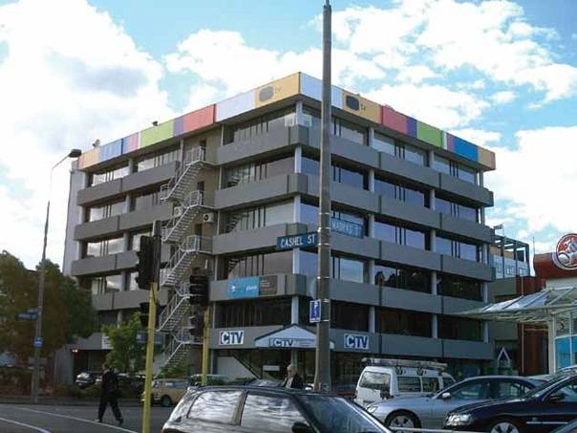Figure 3: The CTV building in 2004. Shown in a photograph from the Hyland/Smith1 report

At the time of the February earthquake, the western side of level 1 was an internal car park. The remainder of level 1 and the whole of level 2 were occupied by Canterbury Television (CTV), a community broadcaster that had been a tenant since 2000. Going Places Education had occupied level 3 of the CTV building, but moved out on 20 or 21 December 2010. This move was not related to the condition of the building. Level 3 remained vacant on 22 February 2011. The principal
tenancy on level 4 was King’s Education, which
operated a variety of language and aged care education programmes. The Clinic, which was a medical centre, moved in to level 5 in January 2011 after a red placard was assigned to the building it had occupied in Gloucester Street. Relationship Services (now known as Relationships Aotearoa) occupied half of level 6 and had done so for some years. The other half of level 6 was unoccupied on 22 February.

Level 1 (ground)
A B C D E F

5 North wall complex

Toilets

Stair

Lifts
N

4
Square column

3
Madras Street

Car park
Demolition site
West block wall
Offices

2

South shear wall
1

Car park

Figure 4: Plan of level 1, which was occupied by CTV at the time of the February earthquake. The finger walls in the north wall complex were shorter on level 1

Level 2
A B C D E F

5 North wall complex
Landing

Toilets

Stair
Lifts
N

4

3
West block wall

2

South shear wall
1
Stair

Figure 5: Plan of level 2, which was also occupied by CTV

Level 3-6
A B C D E F

5 North wall complex
Landing

Toilets

Stair
Lifts
N

4

3
West block wall level 3 only

2

South shear wall
1

Figure 6: Plan of levels 3–6, occupied by King’s Education (level 4), The Clinic (level 5) and Relationship Services
(level 6). Level 3 was vacant at the time of the Boxing Day and February earthquakes

The owner at the time of the February earthquake was Madras Equities Limited, which is recorded on the Certificate of Title as owning the property from 25 March 1991. The building manager was Mr John Drew, who had entered into a contract to purchase an interest in Madras Equities Limited in April or May 2010 and was the owner of The Clinic.

1.2 Structure of the building

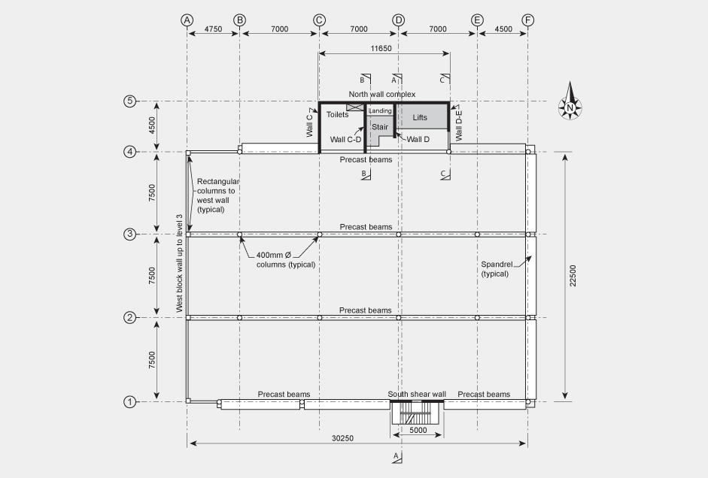

Figure 7:Typical upper floor structure

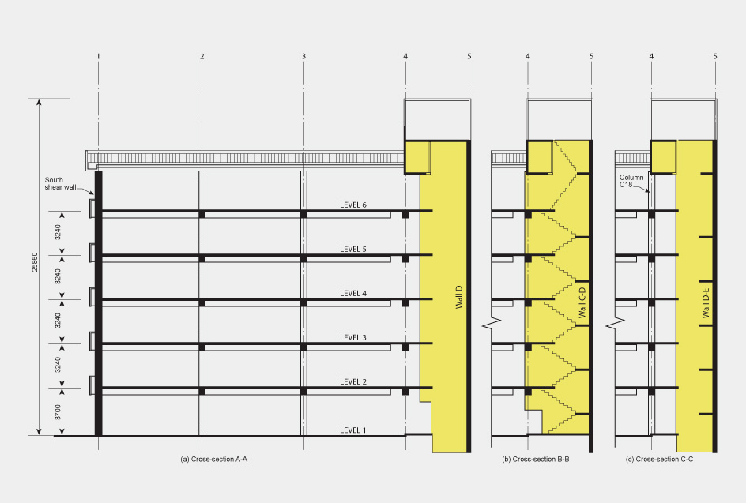

Figure 8: Cross-section looking west near grid line D

(b) Cro ss- sech::m 8-8
f------1

I -
-

(c)Cro ss- sech::m C-C

1.2.1 Original design

The plan dimensions of the CTV building can be seen
in Figure 7, and cross-sections in Figure 8. The building was founded on pad and strip footings bearing on silt, sand and gravels. The above-ground structure was described in evidence as a “shear wall protected gravity load system”. This means that the lateral load resistance in an earthquake was to be provided by shear walls. The columns were only designed to resist gravity loads as it was assumed that the shear walls would limit lateral deflections in the columns. This design approach received much attention during the hearing and will be referred to in detail in this Report.

The north wall complex consisted of an 11.65m long reinforced concrete wall on grid line 5 in the east-west direction with four reinforced concrete walls in the north-south direction. These surrounded the toilets, the stairs and the lifts. This was often referred to as the north core in evidence provided to the Royal Commission. However, the word “core” implies an enclosed structure (such as the shear core of the Pyne Gould Corporation building). As the wall arrangement in this building was not enclosed we have chosen to refer to it as the “north wall complex.”
The south shear wall comprised two reinforced concrete walls joined together by coupling beams on the south face of the building. The beams crossed above the openings in the wall for fire escape doors. We refer to this as either the “south coupled shear wall” or the “south shear wall”.

Reinforced concrete masonry walls were built between the columns and beams on the first three levels on the western side of the building. The floor slabs above level 1 comprised a profiled metal deck on which concrete was poured during construction to form the floors. The composite arrangement of metal decking and concrete was the proprietary product Dimond Hi-Bond. The floor slabs were supported by reinforced concrete beams. The internal beams were precast to the underside of the floor slabs. The external beams on the north, south and east sides were shell beams, which were filled with in situ reinforced concrete when the floor slab was cast. On the west side at levels 2 and 3 there were precast beams spanning between the columns in the north-south direction.

The photographs in Figures 9 to 11 below were taken during the construction of the building. Figure 12 was taken after the building to the west was demolished between the September and February earthquakes.

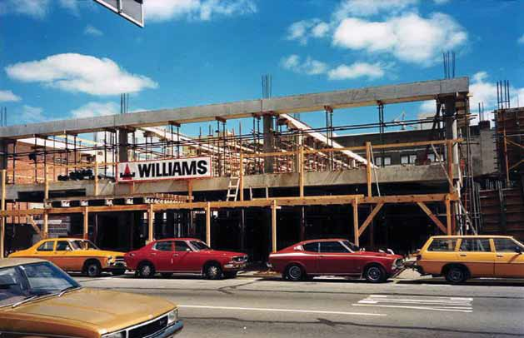

Figure 9: View of the building from Madras Street while under construction. The north wall complex is to the right. The beam structure can be seen, along with the external round columns. The upper beams are “shells” at this point and were filled with concrete at the same time as the floor was poured

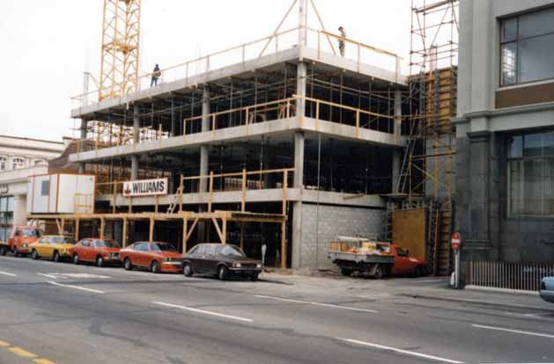

Figure 10: View from Madras Street before the installation of spandrel panels

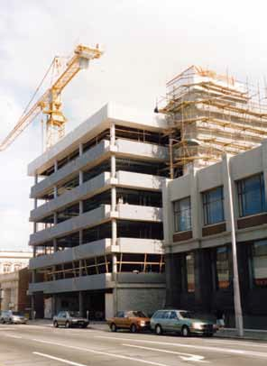

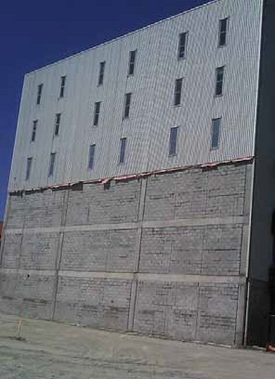
Figure 11: View from Madras Street. The spandrel panels are now fitted, and the north wall complex can be seen covered in scaffolding
Figure 12: Photograph of the west wall after demolition of the building to the west, showing the block wall for the three lowest levels

The majority of beams were supported by circular cast in situ concrete columns of 400mm diameter. The columns contained vertical steel reinforcement surrounded by horizontal steel spirals. On the west face of the building the columns were rectangular, and one interior column on level 1 was square. The columns provided the bulk of the gravity support for the floor slabs, although the north wall complex and the south shear wall also contributed to gravity load support.

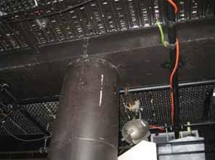

Figure 13: An interior column and beam on level 1

The roof was lightweight steel, supported on steel framing above level 6. Reinforced concrete spandrel panels were placed between the exterior columns at each level above level 1 on the south, east and north faces. These panels were not designed to provide any lateral or gravity load support.
1.2.2 Structural modifications after construction

Following a pre-purchase review for the Canterbury Regional Council by Holmes Consulting Group in January 1990, steel angle drag bars were fitted to the floor slabs and walls at grid lines D and D–E of levels 4–6 in October 1991 to improve the connections between the floor slabs and the north wall complex.

CCC records indicate that holes were to be drilled
in floor slabs for plumbing installations. Holes would also have been drilled for other services. Holes were observed at locations where the slab pulled away from the north wall complex during the collapse. These would have had little or no effect on the structural performance of the building in an earthquake.

A stairwell penetration was cut in the floor of level 2 for installation of an internal stairwell during a fit-out in 2000. Steel beams and a steel post were added to replace the gravity load structure where necessary. This opening can be seen in Figure 5. The penetration did not affect the seismic performance of the building.

Although there were there other alterations to the building, these would have had little or no effect on the seismic performance of the structure. These included:

• the addition of block walls in some parts of level 1
in 1991, which were largely removed in 2000;

• the addition of a canopy to the south-east corner;

• alteration to the entry foyer and canopy on the
north-east corner;

• telecommunication equipment added to the roof;

• the addition of a Lundia shelving system; and

• lightweight partitions on all floors.

The Royal Commission is not aware of any other modifications to the primary structure of the building.

References

1. Hyland C., and Smith, A. (2012). CTV Collapse Investigation for Department of Building and Housing:
25 January 2012. Wellington, New Zealand: Department of Building and Housing.

